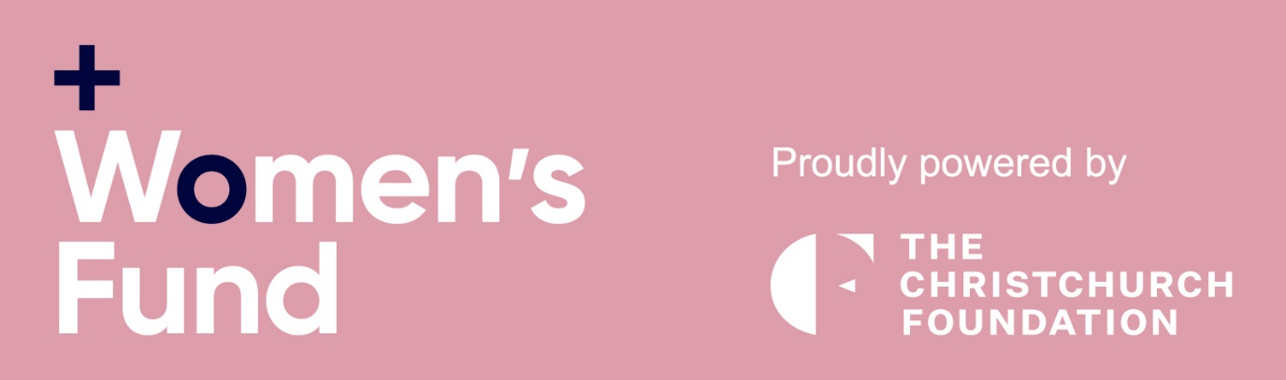

Women’s Fund Application Form
Te Ira Wāhine o Ōtautahi

Your details: Or, you can fill this out on behalf your nominee
Full Name:
Address:
Email: Phone number:

Project Details: Remember we are looking for leaders and change-makers
What is your role in this project? Or your nominee’s role

Please give a brief description of the focus of your project and who benefits (200 words)

What other groups and organisations does this project work with or interact with?

How is the project funded or supported?

Declaration
Please tick here to confirm that the information provided is true and correct
I confirm that the above nominee is aware that they have been nominated (if you’re not nominating yourself).
Date: Name: Signed:

